**Welcome to summer term’s learning for Cedar class.**

This tells you what your child will be learning this term in school. We really value your support and the help that you can give your child with their learning. If you would like a detailed overview of curriculum coverage, please see our website [Felix Primary School](https://www.felixprimaryschool.org/)

Free Book Clipart, Transparent Book Images and Book png Files

**English**

In writing we will be writing a Non chronological report. The text that we will be using is: The Season. We will also be focusing on conjunctions and continuing with our spelling patterns.

In reading we will be continuing with our text Into The Forest and focusing on fluency and retrieval.

Science Clipart Transparent Pictures – Clipartix

**Music**

We are learning about Pitch. We will be learning new songs as we sing and playing high and low notes.

**Science**

In science, we will be learning more about Plants. We will learn about the different parts of plants, learn the names of wild flowers in our local area, Learn about different types of trees and how we can group them into categories.

We also think about the importance of these plants to ourselves and the planet.

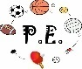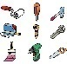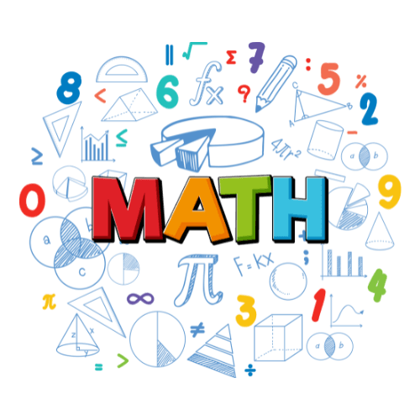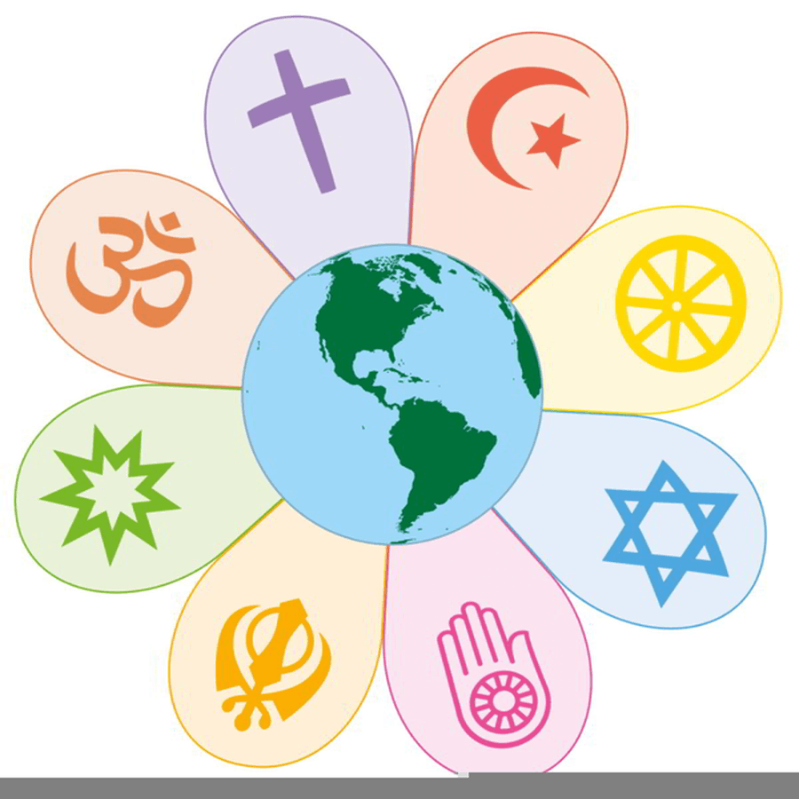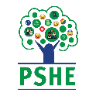Image result for clipart geography

**Phonics**

**We will be continuing to revise and learn new sounds.**

**We will be blending and decoding in all of our reading and writing.**

**Art / DT**

Our topic is Playful making. The children will be looking at sculptures, learning what they can be made from and making their own.

For DT we will be making free standing structures.

**PE**

We will be learning to send and receive in PE. The children will practice aiming at a target, how to catch different sizes of balls and they will use this knowledge to play field games.

**Computing**

We will be learning about Digital Writing. We will be able to create and change text, to use a keyboard and think about the differences between writing by hand and using a computer.

**Geography / History**

In History we will be learning about different types of transport and how our journeys have changed over time.

We will look at how bikes have been transformed. How the uses of aeroplanes has changed and how space travel came about.

**RE**

Out topic is Christianity and we will be finding out what do Christians believe about God.

**Maths**

In maths, we will be counting in 2s, 5s and 10s.

We will recognise and make equal groups and practically participate in completing multiplication problems.

We will then move on to making and sharing into equal groups.

In the final week we will be learning about how to find a half and quarter of shapes.

**HOUSE KEEPING**

* A reminder that we do PE on a Wednesday and Friday, the expectation is that your child bring in their PE kits.
* Dojos will be sent regularly so that you can keep up to date with your child’s learning and support them at home
* If there are concern or queries please do not hesitate to contact myself through the school office, or arrange to book a time to meet with me. I am also available at the beginning and end of every day.