
Are you concerned about the welfare of a child?
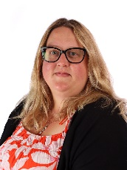
Speak to:


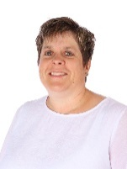
Mrs Hockley DSL

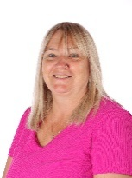

Mrs Clifton ADSL Ms Spurgeon ADSL Miss Rayner ADSL Mrs Beck ADSL
Or contact the school office: office@felixprimaryschool.org 01394 283374
What is the role of the Designated Safeguarding Lead?
The School Designated Safeguarding Lead (DSL) is the first point of contact for any member of the school community who has a concern about the safety and/or well-being of a child. They undertake additional training every two years so they know how to refer concerns to the appropriate investigating agencies and can offer support and advice to all members of the school community. They are responsible for maintaining a record of any concerns and report directly to the school’s trustees.
What is PREVENT?
Prevent is about safeguarding people and communities from the threat of extremism and providing early intervention to protect and divert people away from being drawn into terrorist activity. At our school, it is about being vigilant to changes in behaviour which may be a result of families or communities painting the world as black and white by highlighting division and difference and exploiting fears based on ignorance or prejudice. Education is a powerful weapon against this.

At Felix, we equip our children with the knowledge, skills and experiences to think for themselves and seek help when required. In everything we do, we promote an understanding of the British values: democracy, the rule of law, individual liberty and mutual respect for and acceptance of those with different faiths and beliefs.
Safeguarding is everybody’s responsibility.
Our safeguarding policy is available on our website www.felixprimaryschool.org
The policies and procedures of the Suffolk Safeguarding Partnership can be found on their website www.suffolkscb.org.uk

Our trustee responsible for safeguarding is Roger Margand.
Our trust lead for safeguarding is Michelle Atkinson


Early Help Offer
Safeguarding Procedures | In-school targeted support | In-school universal offer | Referral Routes | Pastoral Support Worker
DSL and 4 alternates | SEND support (see website) | Breakfast club | Play therapy | Home school links
Safeguarding and Child Protection policies | Specific screening available | Wrap around care | School nursing team | 1-1 support for parents
Regular staff safeguarding training | EHCPs | After school clubs | Suffolk wellbeing hub | Be the voice of parents in school
In-school safeguarding reporting for staff | Specialist Education Services | Play leaders | Suffolk Inclusion Services | Signposting to other agencies
Online safety lead | Speech and language | Parents evenings | Parenting courses | Support with online applications
Consultation line support for DSLs | Additional adult support for children | Reading cafes | Young carers | Advice on practical childcare and parenting skills
 | Lunch club | Transitions | Winston’s Wish | Pastoral interventions with groups and individuals
 | Level 2 | Support from Educational Welfare Officer | Homestart & The Compass | Trusted adult for children and parents / carers
 | Risk assessments/Care plans/ Behaviour support plans | School Website | Health visitors & Children's centre
 | Reading/maths interventions | School Newsletter | Lighthouse
 | SEND coffee morning for parents | School Nurse weight/height Rec and Year 6 | Restitute
 | CAF / CIN / CP support with safeguarding team | PSHE and assemblies from PCSO etc | Suffolk parent carer network
 |  | World of Work | SENDIASS
 |  | Enrichment | Activities unlimited
 |  |  | Safeguarding—EHA and MARF

