**Welcome to summer term’s learning for Maple class.**

This tells you what your child will be learning this term in school. We really value your support and the help that you can give your child with their learning. If you would like a detailed overview of curriculum coverage, please see our website [Felix Primary School](https://www.felixprimaryschool.org/)

Free Book Clipart, Transparent Book Images and Book png Files

**English**

In writing we begin the half term writing a Narrative. The text that we will be using is: The Nowhere Emporium. The children will spend two weeks in teacher led classes building sentences and a week plotting and writing their own continuation of the story. During these lessons we will also be concentrating on handwriting, KS2 punctuation, relative clauses and our spelling patterns.

We will end the half term looking at a non-fiction report on Mars.

In reading we will be reding the text The incredible Ecosystems of Planet Earth and focusing on fluency and inference.

Science Clipart Transparent Pictures – Clipartix

**Music**

For music, we will be listening to music, creating and performing music related to compositions for the festival of colour, which is closely linked to the Holi festival. This will strengthen the children’s knowledge and understanding of using music to express themselves which we previously learnt about in our last unit.

**Science**

In science, we will be focusing on the reproduction system of mammals, male and female parts. We will also be looking at how asexual plants clone themselves in order to reproduce.

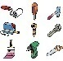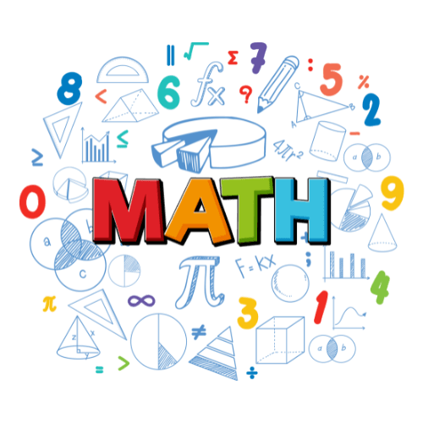Image result for clipart geography

**Computing**

We have an exciting half term in computing where we will become Graphic Designers. Our focus is to look at vector shapes and see how designers manipulate shapes, use layers in order to create designs that we all know and love, such as Nike, Adidas and many more. The children will get the chance to create their own on the chromebooks.

**Languages**

In French, we will recap some prior learning looking at some French grammar and understanding why and when we need to use masculine or feminine form. We will move swiftly on looking at verbs and activities we do. We will incorporate this with telling the time in French and recapping numbers.

**PE**

We will continue to have swimming on Wednesdays please come to school in school uniform with a swim kit in a named bag. Please remember to bring a swim hat.

On Tuesdays, Maple Class will be participating in Cricket with Mr Entwhistle. Please come to school in correct, weather dependent PE kit. Year 6’s will have PE on Friday with Mr Humphrey, please wear your PE kit to school. Mr Humphrey will be teaching Tennis.

**Geography / History**

In History, we have gone back to our Conflict and Resolution unit. Previously, we looked at World War 1 and the impact it had on Britian and Germany and how we were able to resolve a conflict. This term, we are zooming in on World War 2 and how it came about. Our knowledge of World War 1 will help to reinforce our learning and look for patterns in conflicts and how we resolve them throughout history

**PHSE**

PSHE this term will focus on relationships and how we can stay safe online, within the community and whilst we are doing gaming. It will also enhance the children’s prior knowledge of how they can stay safe, what they should do if they feel unsafe and how we can use screen time and the internet as a happy place.

**RE**

This half term we are exploring Judaism and talking about why forgiving others is important in Judaism. We will explore the term forgiveness and why having the time to reflect and review is important in Judaism.

**Maths**

In maths, we will start the term by looking at shape including angles, how to draw lines and angles accurately, make estimates and calculate unknown angles. Towards the end of the unit, we will look at regular and irregular shapes. We will move onto position and direction, plotting and translating coordinates, moving onto symmetry just before the end of the half term.

**HOUSE KEEPING**

* A reminder that we do PE on a Tuesday (Yr 5 and 6) Swimming (Yr 5 only) on Wednesday and Friday (Yr 6’s only)the expectation is that your child comes to school in their PE kits on Tuesday and Friday (Yr 6’s only) and on Wednesdays brings a swim kit in named bag.
* Dojos are given when displaying and following the school rules and values. Please continue to check Dojo for regular class updates, pictures of your child’s work and keeping track on their points.
* If there are concern or queries, please do not hesitate to contact myself through the school office or arrange to book a time to meet with me. I am also available at the beginning and end of every day.