**Welcome to summer term’s learning for Willow class.**

This tells you what your child will be learning this term in school. We really value your support and the help that you can give your child with their learning. If you would like a detailed overview of curriculum coverage, please see our website [Felix Primary School](https://www.felixprimaryschool.org/)

Free Book Clipart, Transparent Book Images and Book png Files

**English**

In writing we are working hard to show off our accurate grammar and punctuation and we are very proud of our beautifully presented pieces in our best books. We will be writing a narrative, a diary about a homeless child and an explanation text about a marvelous invention. I can’t wait to read them!

Science Clipart Transparent Pictures – Clipartix

**Music**

In music, we will be composing and performing our compositions. We will also be learning the songs for our upcoming production – keep your eyes peeled for more information.

**Science**

In science, we will be looking at adaptations – how animals and plants have adapted to the environment in which they live. Next half term, we will look at fossils and see what we can discover about animals and plants from the distant past!

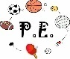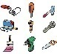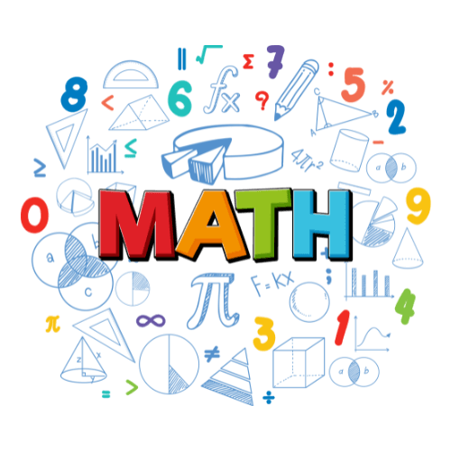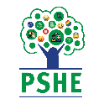Image result for clipart geography

**Languages**

We will continue with French On Mange! In this unit we will learn how to name different foods and drinks. Our next unit will be Le Cirque!

**Art / DT**

In art, we will be creating shadow puppets and in DT, we will be celebrating culture and seasonality in food.

**PE**

For the summer term, we will be improving our athletics skills with long jump, high jump, discus, javelin and sprinting. We will also take part in outdoor adventurous activities (OAA) individually and as a team.

**Computing**

In computing, we will be completing some 3D modelling through our Creating Media topic and we will continue with our learning on programming with a focus on sensing movement.

**Geography / History**

We are currently finishing off our history unit of Conflict and Resolution, learning the impact of WWII on modern day society. In geography we will learn about global challenges in the world, focusing on trade.

**PHSE**

In PSHE, we will be celebrating difference and learning to understand others, showing tolerance and respect. We will also consider changes and our emotions around these as we prepare for our transition to high school.

**RE**

Our RE topic this term is Hinduism and we will spend some time learning about the world view, humanism.

**Maths**

In maths, we will be ensuring we are high school ready with lots of arithmetic practice. We will look at position and direction in shape and spend some time completing some open-ended problem-solving tasks to keep our brains working!

**Languages**

**PSHE**

**HOUSE KEEPING**

* A reminder that we do PE on a Tuesday and Friday and the expectation is that your child wears their PE kit on these days.
* Please keep an eye on Dojo for any updates, including positive points for behaviour!
* If there are concerns or queries, please do not hesitate to contact myself through the school office, or arrange to book a time to meet with me. I am also available at the beginning and end of every day.